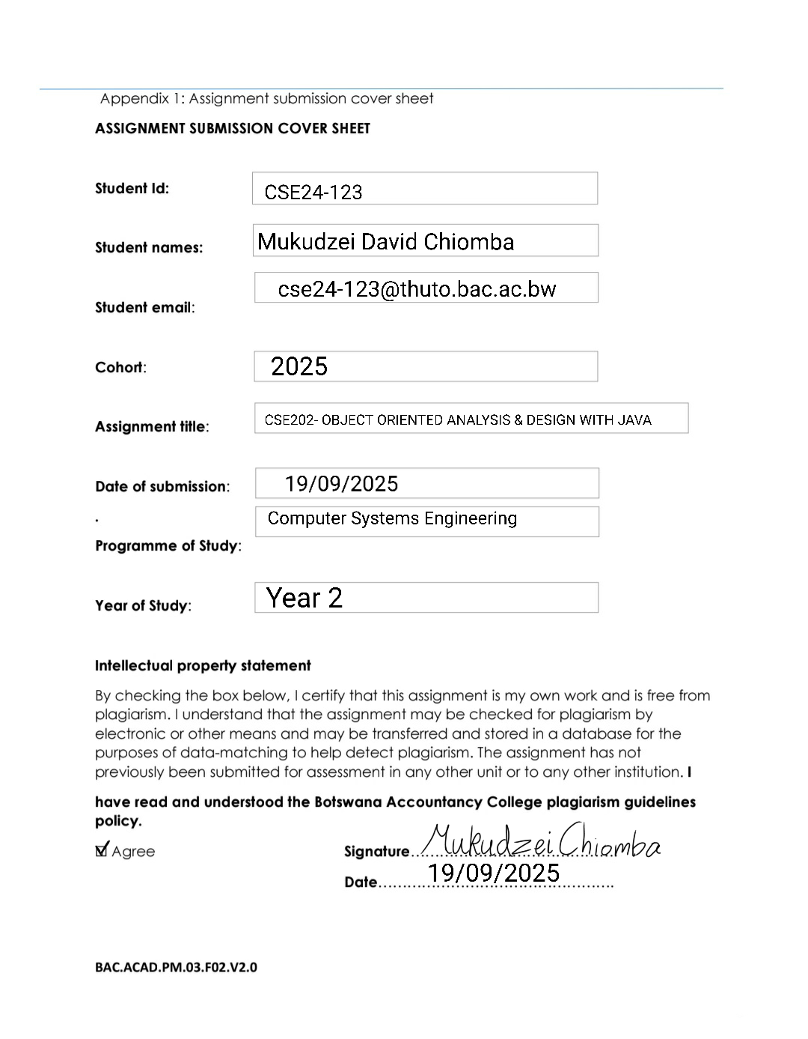

**Part A: System Documentation**

Requirements Elicitation

Functional Requirements

Mukudzei Chiomba – What information should be entered when a customer creates an account

Themba Moeng - So basically some of the information is stated as per the scenario. Unless we expect that beach uniquely identify a customer that could be coming from their ID numbers or their passports.

Numbers. We expect the personal interest such as names, gender, etcetera. We also expect presidential information and also we expect the employment information in terms of where they work.

We also need to provide the login credentials, session name, the passwords, yes.

Yes.

Mukudzei Chiomba - My second question is, can customers make multiple accounts?

Themba Moeng - Yes, that is also stated. In the scenario so you can have however many accounts you desire and also different types, yes.

Mukudzei Chiomba - What are the types of accounts that can be made and do they have interest and what are the interest rates?

Themba Moeng 1 minute 30 seconds

This these ones are staged in the scenario, so just pick this the answers from the scenario.

Mukudzei Chiomba - What are the maximum and minimum amounts that a customer can withdraw or deposit into each type of accounts?

Themba Moeng - Yeah. Well, basically like the investment account, we do not allow you to withdraw beyond the minimum balance or deposit amount. And then the other ones we can allow you to withdraw, but we don't allow. The overdrawing mean you will don't allow you to go into the negative.

Non-Functional Requirements

Mukudzei Chiomba – What is the level of security that is expected for each for user authentication? Like should you do 2 factor authentication or just the username and password?

Themba Moeng - Yeah, for simplicity, we'll use what username and password and also we don't have the gateways to for the e-mail or gateways through SMS. So we just use the simplistic approach.

Mukudzei Chiomba - For the system performance expectations such as response time for chance, what should be the general response time for transactions and maximum system load?

Themba Moeng - Yeah. Basically, we're expecting a maximum response time of three milliseconds when performing simple transactions and then basically we are expecting that they keep the system should be capable of 200 simultaneous transactions.

Mukudzei Chiomba - Should the system have the ability to create backup data in case of data loss?

Themba Moeng - Backups are expected of any system, but normally this is not what we'd code as part of the system. It will be achieved through another utility, so that's when it's out of scope.

Mukudzei Chiomba - How should the general user interface look and feel and how user friendly should it really be?

Themba Moeng - OK. So in terms of the look and feel that that is up to you as the as the designer make it interesting and like eye-catching make it as colourful as and professional as possible and obviously the in terms of the user friendliness we expect you to have what?

Easy to understand the labels and also alerts or error messages. They should be simple and straightforward to a non-technical person and obviously since this system is used by the general public. If you didn't require new users, a new user to be trained to use the system.

Mukudzei Chiomba - Do you expect for there to be further expansion of the system and more things to be implemented later on in the future?

Themba Moeng - Yes, since we have specified a limited scope, they should be scope for adding new features as time goes on.

Structural UML Modelling

Use Case Diagram

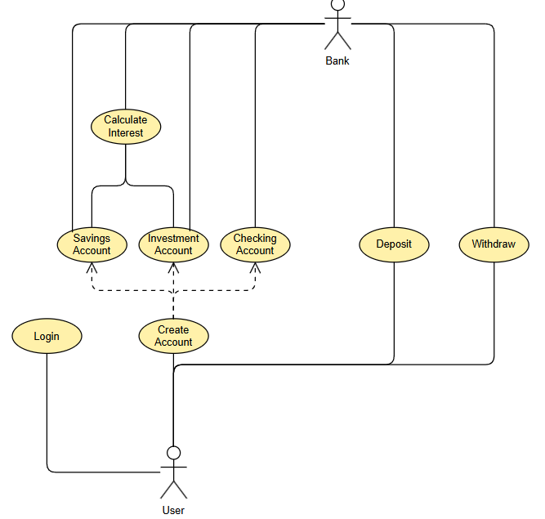

Class Diagram

Sequence Diagrams

Login

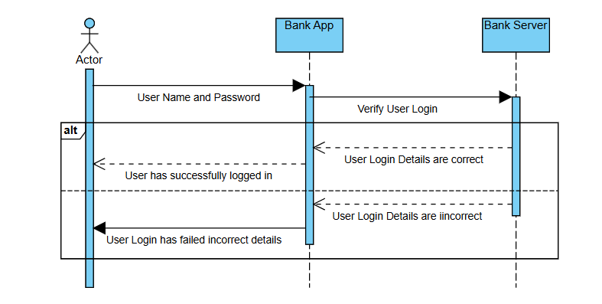

Deposit

State Diagram

